Title : Private spaces : collective pages
Author name : GAStyZ drawing group GSA
Affiliation: Glasgow School of Art

Contact author: Frances Robertson Department of Historical & Critical Studies, GSA
Fr.Robertson@gsa.ac.uk

This article is a descriptive reflection on an independent drawing project that took place during the presentation of lecture course on philosophies and practices of drawing that was written for undergraduate students at Glasgow School of Art. The independent collaborative project thus aimed to continue this process of self-reflection through finding a way of discussing aspects of the theme of Fragmentation through the process of drawing, collaboration, and discussion. The article presents three different writing voices and responses to the project, and also shows some of the drawings that were evolved through a deliberate process of alternation and play between subjective private imaginings and collective narrative expression. The project also presents one example of how different registers of knowledge and experience: practical, theoretical, student, and teacher, might be brought into
dialogue with one another.

PRIVATE SPACES: COLLECTIVE PAGES

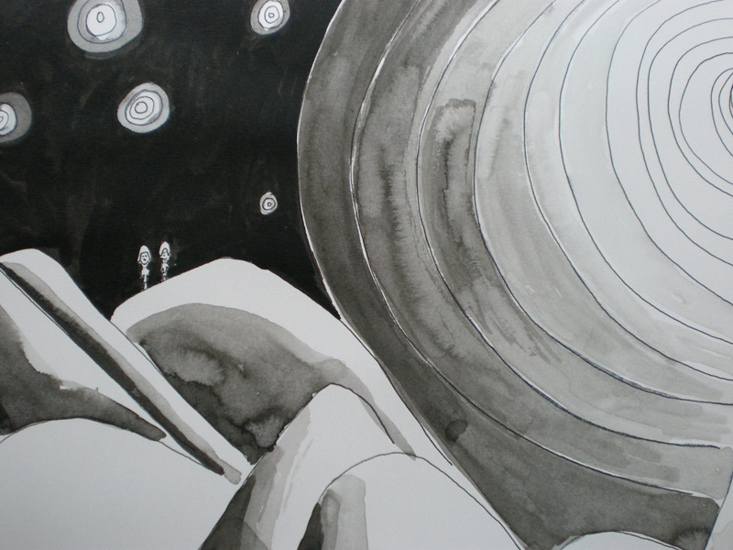 fig 1: copyright Michelle Letowska

This article is presented by the writing and drawing group GAStyZ –our name is a readable mash-up of part of the blogspot address http://gsahcy2t2drawing.blogspot.com which is the site of the Glasgow School of Art undergraduate short course Marking the page: philosophies of drawing run by the department of Historical & Critical Studies, and our group is an independent offshoot of that course. Briefly, the ambition of the official taught course was to find a way to discuss aspects of contemporary drawing practices that undergraduates currently confront, and to reflect on some of the assumptions behind some of the most common drawing conventions that students are exposed to in their artistic formation. Formation here is understood to be the process that extends from the infant classroom, through to the arduous process of portfolio preparation and beyond. The course was written for Year 2 undergraduates in the 4-year Scottish degree system, so the students on the course are thus at the start of an intensive but mysterious period of self-formation within the academy. The structure of the course aimed to echo this process and to share elements of the student experience and knowledge whilst the course was running, so the trajectory of questions addressed in weekly lectures was interspersed with the responses through the medium of student postings to the course blogspot. Setting up our informal short-term drawing and writing group GAStyZwas a way of further extending that dialogue through an independent collaborative project and attendance was completely voluntary.

This article has been prepared for Tracey by the writing residue of that group. Addressing the theme of fragmentation gave us a working procedure and a focus for discussions. Three of us from the independent drawing project have each written part of this article: one undergraduate student, one new graduate, and one oldish lecturer. GAStyZ, however, is larger than that, and includes everyone (mostly undergraduate students) who came into the project as a drawing volunteer. All the participants who took part are listed at the end, and aspects of the project are discussed by all three writers. This article is not so much a report of events, but three sets of reflections on contemporary drawing practice and theory that were prompted by that experience.

1: Frances Robertson: Lecturer, Glasgow School of Art Department of Historical & Critical Studies
When I wrote the lecture course, and then devised the independent drawing project, I intended to bring into consciousness some of concepts and influences behind some of the most common drawing practices that students have used in their artistic formation. Thinking about context in this way, I realise, exposes not just my own Postmodern tendency to believe that new work is cobbled together out of scraps of borrowed, copied or appropriated imagery or gestures, but also the fact I think it is important to be aware of this. If you pressed me further about borrowing, I’d probably say, ‘so what?—originality and borrowing are not opposed to each other anyway—it’s new work and no work that are opposed’.

However, what I’d like to talk about here is not so much whether appropriation takes place, but where those appropriations are taken from, and the ways they are used. Discussions of artistic formation or surveys of contemporary drawing practice, I argue, consider a relatively restricted range of influences that are largely confined to the artworld, and a particular section out of an individual’s life. Looking at the student postings on the blogspot, and sharing in the drawing, development and discussions of the collaborative GAStyZ suggested it would be useful to think further about the appropriations of drawing from beyond that frame.

Drawing is a more inclusive and a more universal cultural practice; it is something that begins very early in life in many cultures and for all sorts of purposes beyond art. In the modern West, a drawing implement is thrust into a child’s hands before she can talk. However, I do not wish to suggest that the outcome is some universal visual language of humanity. In his article ‘Primitivism, the avant-garde and the art of little children’, Brent Wilson (1992: 20-22) has argued persuasively that small children pick up the prevailing visual conventions that they see, and will draw in ways that are as culturally specific as those of any academy student. For example, Western children’s visual programming begins with drawn images and an engagement with the imagined lives of such characters as Spot, Mog, Peter, Tintin, the Moomins, Mickey, or Bart.

In the brief for the drawing project I had suggested that we each draw one page of a comic book or graphic novel that would be based on some common elements such as characters and objects that we would first choose jointly after a session of intensive drawing. The reasoning was that creating a page would give us cause to notice our choices about the use of composition, perspective and pictorial balance in the process of drawing. The second part of the project, bringing each individual fragment (page) of narrative together, and discussing how they should be ordered as a whole, was intended to prompt considerations of the uses of narrative in drawing. However, in the event, I saw instead that concepts of narrative and self-expression, when allied with the invitation of the comic book page, opened up a nostalgic parade of loved images and conventions first encountered in childhood from all the drawing volunteers (including myself).
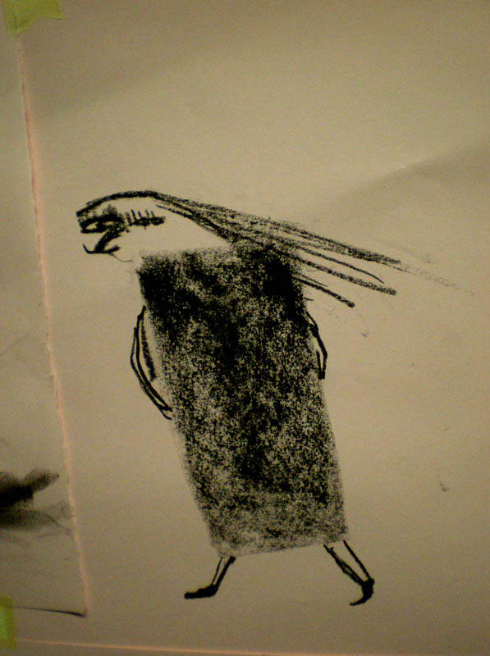 fig 2: First sketch copyright Frances Robertson, before election to antagonist

Hence it was only after the character that Aileen called ‘Mrs. McGinty’ was elected to be the antagonist in the narrative we could see she bore a resemblance to characters both from Tove Jansson’s much-loved Moomin books mixed with a dash of Mrs. Twit.

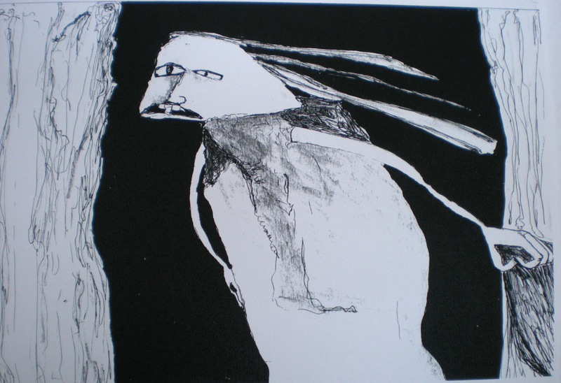fig 3: Remastered version copyright Aileen Crossley
In a similar vein, a good proportion of the objects we drew and then nominated appeared to have come straight from the properties box of distinct though competing narrative genres, and already highly charged with dramatic significance: telescope; magnifying glass; rag doll; ladder; key; and finally, a black hole. Other objects were more random, such as a cheese grater, a goldfish bowl, a lawnmower or a jelly. Both the symbolic language and the kinds of mark-making used to make these apparently random objects and characters were taken from the visual language of children’s storybooks, whose studied dash and naivety is modeled in turn on a certain notion of child art as a site of free play and spontaneous creativity.

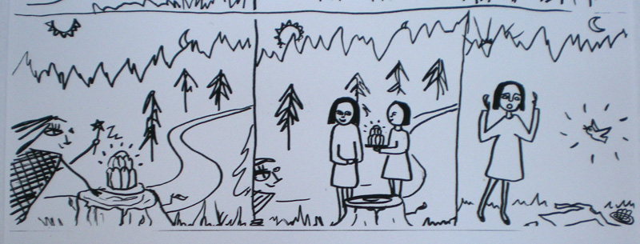fig 4: Copyright member of GAStyZ group

Brent Wilson (1992) criticized such ‘modernist notions’ of originality and creativity in child art, arguing that the doctrine of spontaneous creativity enforced by generations of kindergarten teachers, and then reinforced by a ‘childlike’ style in their picture books, had kept children from studying and copying the works of other artists, and thence from developing a true art education. It appeared to me in reviewing the project that, having suggested the task of producing something in some kind of storybook format, many of us had dived right back to the hours of drawing practice we put in within those very conventions of the childlike. So while Wilson was concerned that children would be corralled into the ‘child’ style and hindered from copying the work of adult artists, I am turning this around and suggesting that when we look at the work of adult artists, we should not forget the long years of child style drawing practice that went into the formation of our adult repertoire.

A second aspect of the drawings that are studied with the special attention of childhood is that they are mainly printed images, with distinctive visual qualities that are derived from that medium. Such images don’t just teach us how to draw, but how to look as well, and childhood practices of looking differ from the distanced self-awareness that is so prized in professional training in higher education.

Printed images are frequently theorized in two distinct and familiar ways in cultural theory: firstly is the idea that the free circulation of printed texts and images has led to a more rational, modern, and secular society, and secondly, to art and design students maybe even more familiar, is the notion of the ‘work of art in the age of mechanical reproduction’ derived from the still-influential writings of Walter Benjamin in the 1930s. In this way of thinking, prints are often conceived as secondary to original artworks. Drawings by contrast, are often imagined as the original of an original, the most authentic version of the artist’s first thought. But such interpretations do not really fit the way that drawing for print is received by children, when storybook characters are imbued with life by their viewers, and the drawing does not exist in any true sense outside the printed page.

Print mediums have a unifying effect on the images that are brought to them. In the drawing project we started out with many fragments of images, made with different marks such as pen, biro, charcoal, etc. Each fragment then was circulated around and remastered by each participant, as we saw in the example of Mrs. McGinty above, and finally our separately-drawn pages were photocopied in order to create a sequence, for example the four pages below.
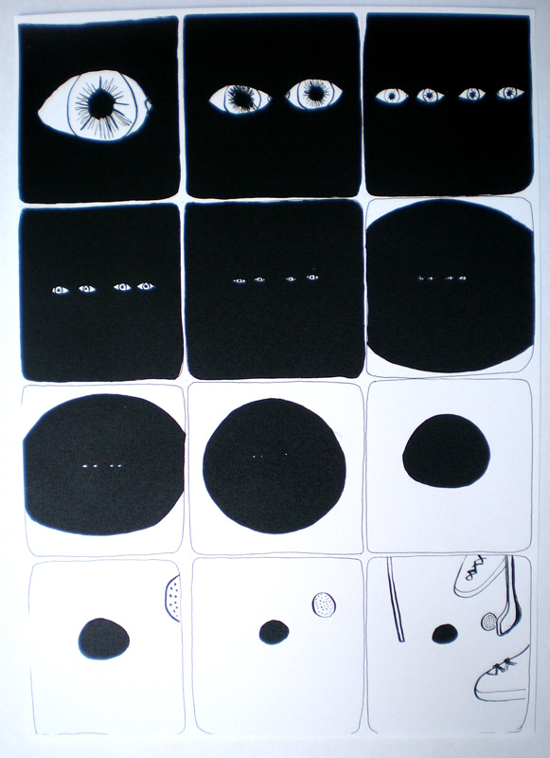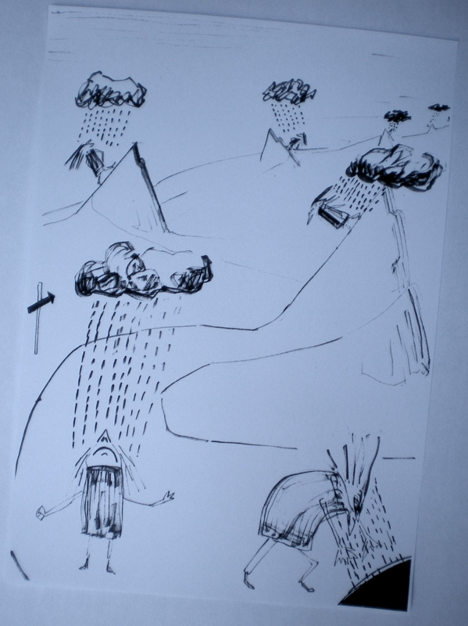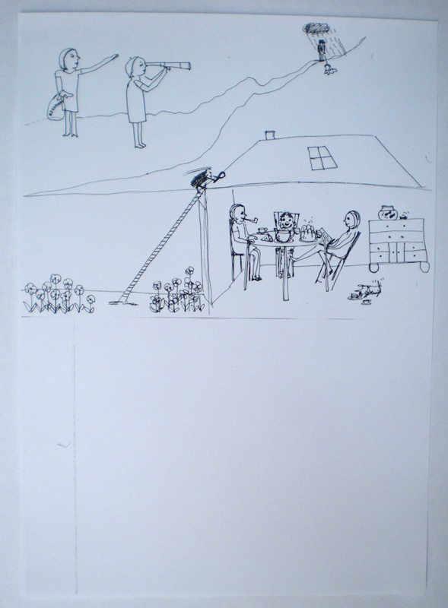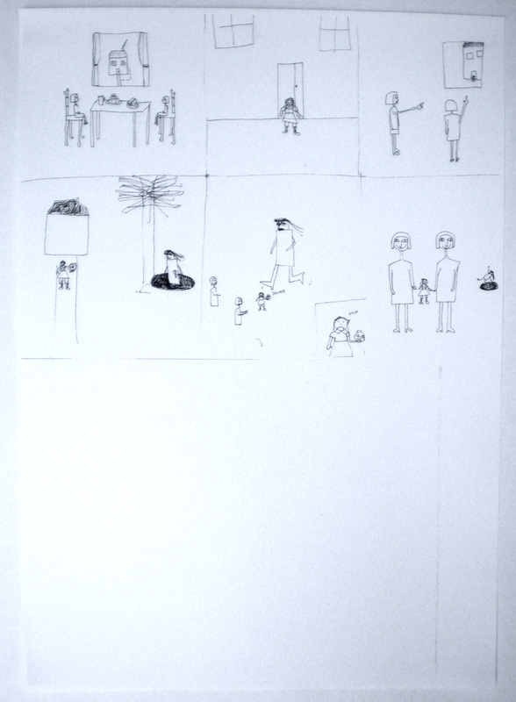
Figs 5-8: Copyright members of GAStyZ drawing group GSA

This amalgamation, circulating, and sharing of images allowed me to see in action how linear drawing and print is able to pull together fragments of space, time and memory. We can see a similar process in the work of John Flaxman’s famous outline illustrations of the late 18th century. Flaxman derived his style from an eclectic array of sources separated from each other and from his immediate predecessors in time and space. His style was thus not inherited from his training in academic drawing, or from other expected two-dimensional sources such as prints or paintings. Instead, it was derived from surface decoration of crafted objects (ceramics) or from sculptural free-standing figures, tomb monuments or classical low reliefs. Sarah Symmons suggests that by reducing such disparate sources to ‘a uniform colourless line’, Flaxman allowed these styles to sit together, whilst displaying them to the educated connoisseurial eyes of his patrons. (Symmons 1984: 45; 80-2)

Finally, as we veer from page to page, and from one manifestation of a character to another, drawn by several hands, the motley mixture of sketchy and cartoony mark-making also demonstrates by juxtaposition that line doesn’t just bring styles together from many places in time or space, but that it allows character to grow out of gesture, in the way described by Rodolphe Topffer (1799-1846), arguably the first strip cartoonist. Topffer asserted that physiognomy and characterisation doesn’t grow out of observation, but out of the autonomy of the line on the page: ‘every head, however badly drawn, necessarily has a distinct expression’. Topffer esteems line above all other pictorial elements, because in his opinion, even a badly-drawn line makes something.

Let me briefly describe the project to you with more detail before adding my own overall response to what I found out throughout the whole process of teaching the course, reading the blogs, and then taking part in the project.

The common visual elements we agreed through discussion, drawing and voting were:
i) which period in time will the story be set in? (contemporary) ; ii) what kind of spatial environment are we going to set it in? (rural) ; iii) 3 characters –one protagonist, one in opposition to main character, one minor character (we drew, then voted) ; iv) one or more significant objects (again, we drew, then voted). For example, here is part of the ‘identity parade’ of characters we drew rapidly and intuitively during our first meeting and about to be voted on for inclusion in the narrative.

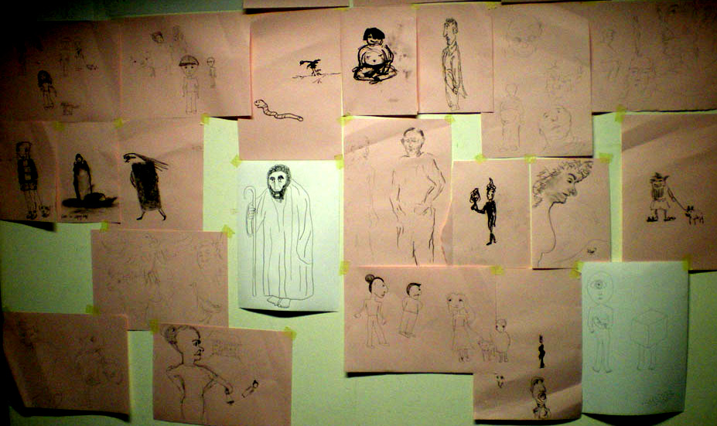 fig 9

The narrative elements that we agreed on then prompted a story or an episode from a narrative to form in our imaginations. Each of us selected a fragment of our private narrative that would fit one page, and drew this out in A3 upright format using black on white, in any medium of choice, knowing this would be photocopied and reduced to A4 format on the office photocopier. Having completed one or more pages in our own time, we then got together for a second group meeting.

We brought all these pages together and discussed the possible narratives that had come out this collision of fragments of our own personal narratives. As we assembled the pages into different orders in a playful way, we were also asking how we read the images, and what skills and assumptions about mark-making, and composition we had used:

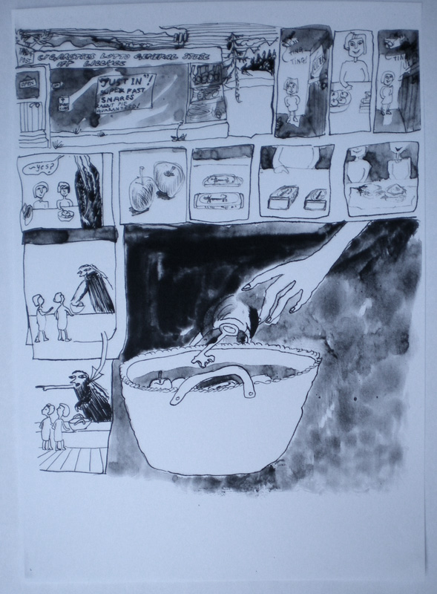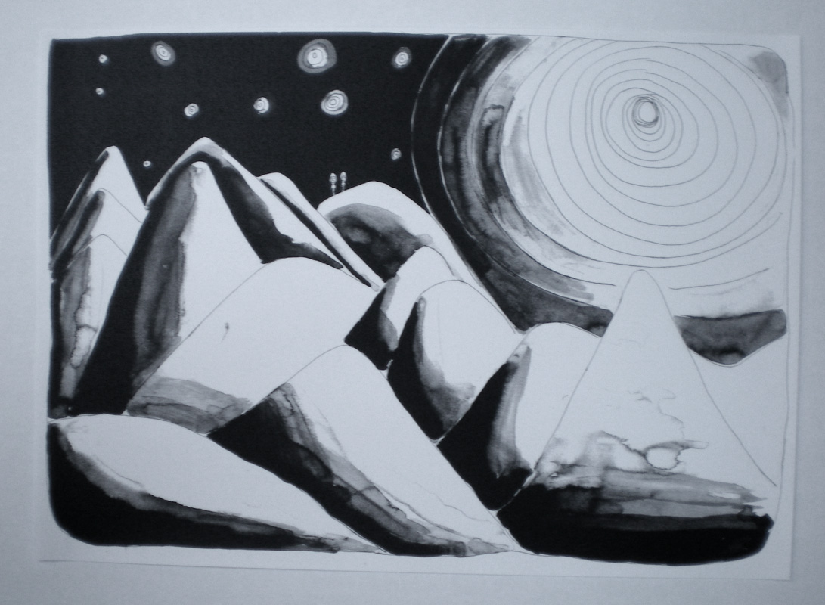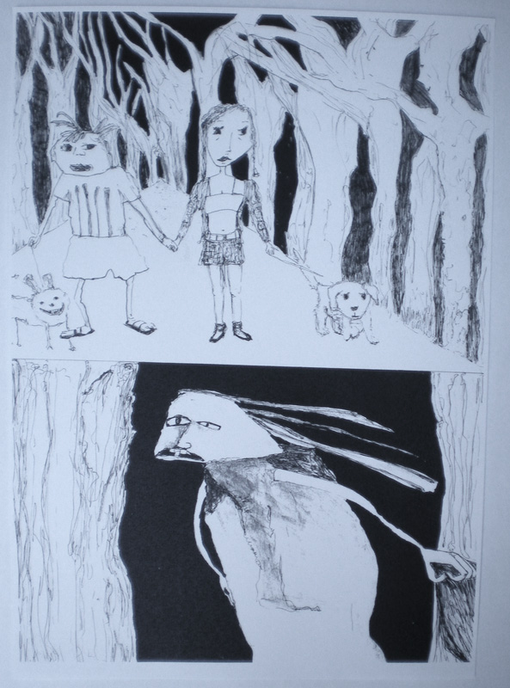
Figs 10-12: Copyright Frances Robertson. Michelle Letowska, and Aileen Crossley

2: Aileen Crossley: undergraduate student, Glasgow School of Art, Department of Visual Communication
Collaborative Drawing Project thoughts
For me, the collaboration of a number of artists together, drawing “blind” narratives has been a great experience in a number of ways.
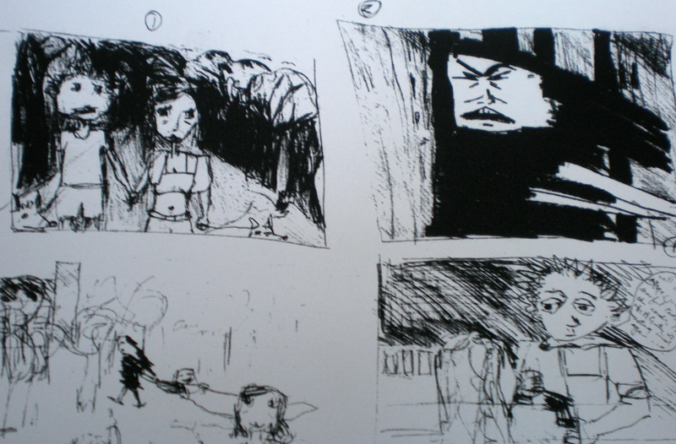 fig 13: Copyright Aileen Crossley thumbnails

There is what you could term as a “dilution of responsibility” on any one artist to “produce” perfectly finished, polished drawings, there is much more of a sense of freedom both creatively and in terms of drawing style. I felt that because the onus was not on polished finished works, I worked in a much looser way than I would normally and because I was less inclined to rip up a page and start again, the results were much more interesting. I realised that I should have more confidence in the page I am working on.

The initial brainstorming exercise from which arose characters and object, which we took away to use for our individual drawings, led to my trying out different drawing styles in order to replicate in my own way, those characters drawn by others. This exercise helped me loosen up in terms of drawing caricatures, and helped me avoid drawing in my usual style and proved that I can be more creative in terms of drawing style, and to research other artists more.
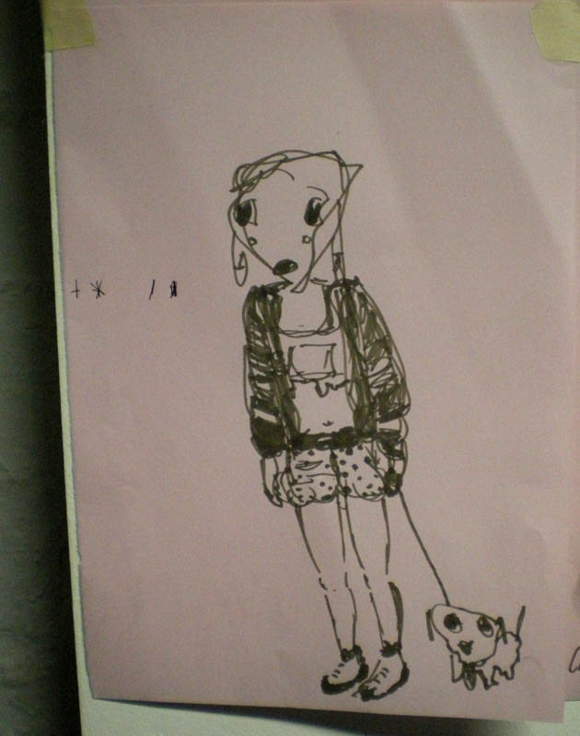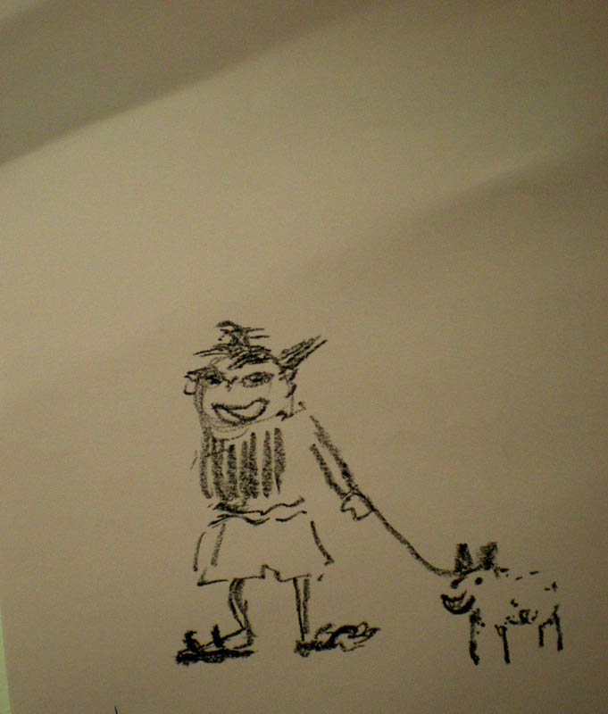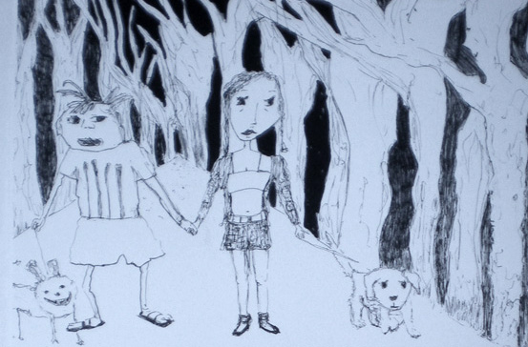
Figs 14-16: Copyright members of GAStyZ drawing group GSA and Aileen Crossley

In terms of narrative, scenes of vastly different tone and mood became apparent with strange worlds juxtaposed together. The randomness of these ideas and styles made for an exciting and very usual world.

A fellow illustrator friend of mine creates a diary every year, she hands out a blank month for 12 individuals to illustrate every page of that month. Every month sees individual style of illustrations or doodles. It is a collaboration of illustrators in a fun project that each year goes from strength to strength.

Now, having being involved in this project, I feel that if I was to write and illustrate a novel, I would ask friends to doodle characters for me, just to help me create more varied and interesting drawings.

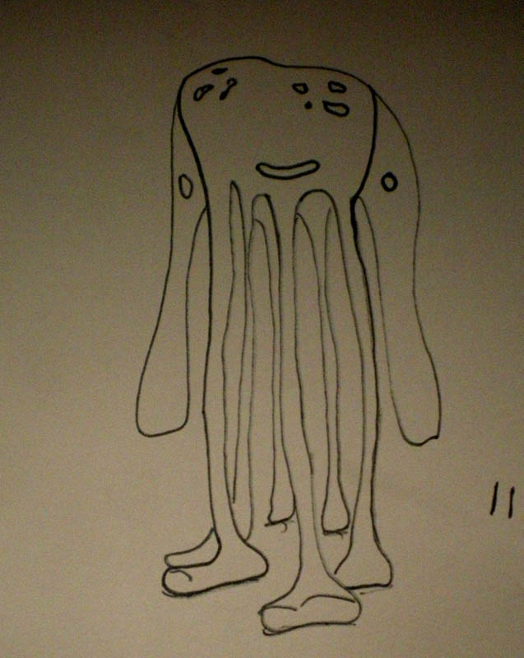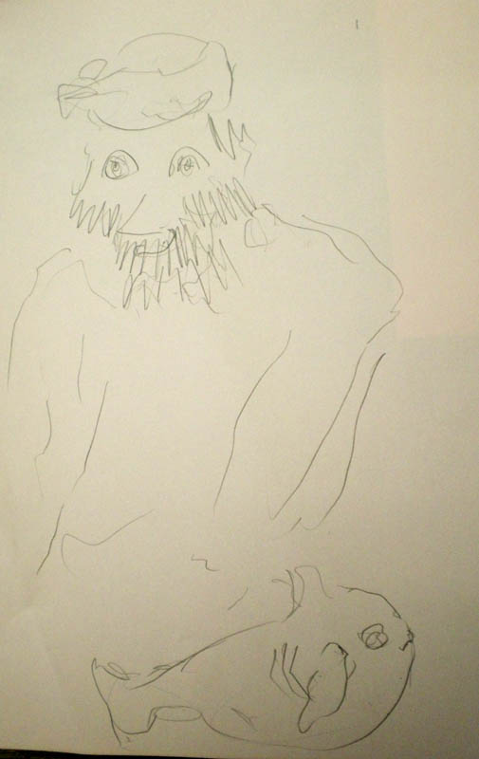
Figs 17-18: Copyright members of GAStyZ drawing group GSA

3: Michelle Letowska: artist and writer, Glasgow School Art graduate
Some fragments are smaller than others

“When one talks less, one starts feeling more fully one’s physical presence in a given space” (Sontag 1961)

This is all a fragment of my imagination.

I place myself in the page, into its whiteness and silence. I find myself in it and wait for something to happen.

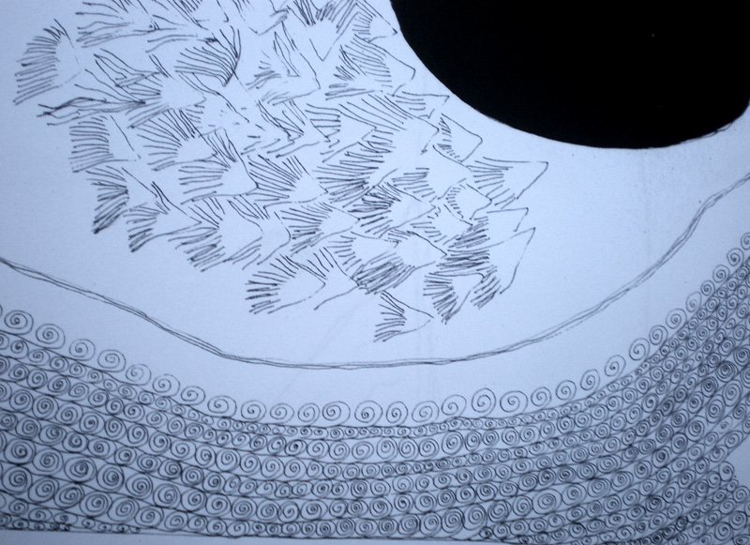fig 19: Copyright Michelle Letowska detail of drawing

Fragment - as Drawing - is both noun and verb.

To fragment is to break.

A fragment is a part of the broken.

In creating a space, I fragment a story.

The story is broken by my page.

To fragment, the verb, as much as drawing the verb was as important as the drawing and the fragment as nouns.

Drawing gave time and space to ideas.

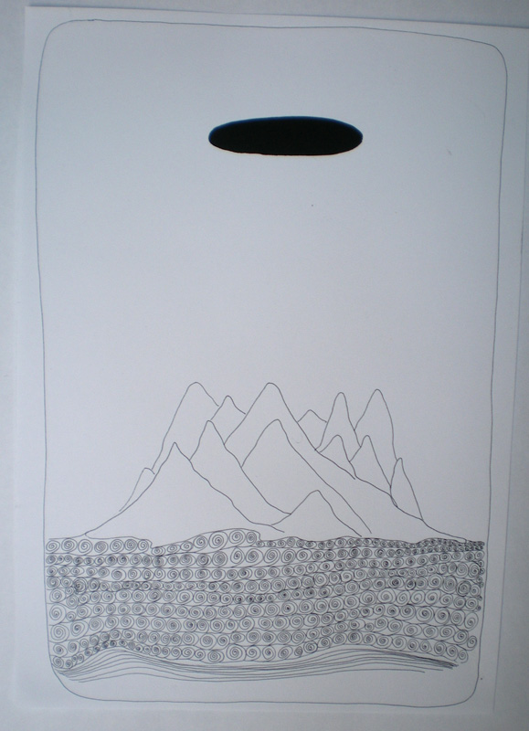 fig 20: Copyright Michelle Letowska
Only when the pages of our story were brought together did I realise what I had done. Only in relation to the pages of others did I realise mine were the tiniest fragments of all.
No attempt to create any story, no narrative, no trajectory constructed for the characters, the objects or the events. Other contributors offered pages in which a story unfolded, into which other pages could be inserted, moved around, woven in. I had pages to fragment the plot. Busy pages full of silence and nothing. My images were to be carried along by someone else’s direction. They would be part of something else, be part of something bigger, but their silence would draw everything else in.
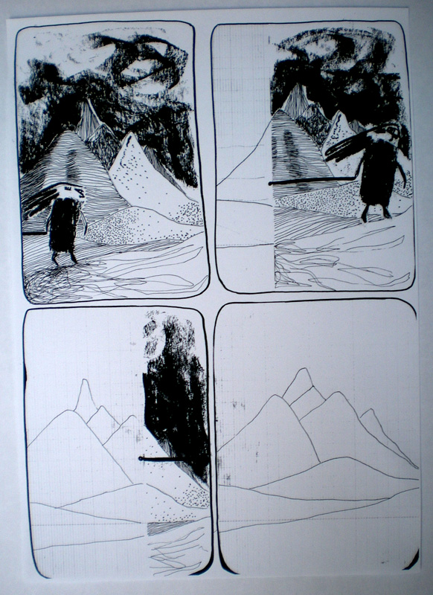 fig 21: Copyright Michelle Letowska

I knew what the place would feel like - what would occur, would occur.

Frances Robertson—some conclusions: In the call for submissions from Tracey, we were invited to reflect on whether or not contemporary drawing practice is characterized by fragmentation, insofar as postmodern art does not seek to find the one authentic style or mode of expression, but revels in a patchwork of borrowings in the way described by Bernice Rose (1992) as allegorical. Rose called on this notion of allegory, derived from Walter Benjamin, and more recently expounded in an essay from 1980 by Craig Owens, in which he stated: ‘allegorical imagery is appropriated imagery… [the artist] lays claim to the culturally significant, poses as its interpreter’. (Owens 1992 [1980]: 1053)
Although the material produced in the drawing project could have been interpreted in this way, I have instead chosen to develop a different interpretation that considers elements of analysis that have gone into eclipse in more postmodern times. Discussions of artistic formation or surveys of contemporary drawing practice, I argue, consider a relatively restricted range of influences that are largely confined to the artworld. In this framework the imaginary artist and audience are adult, educated, and distanced to some extent from their experience; that is the aim and function of the academy today. Within this closed system, a sinister and yet ineluctable meaning of appropriation can become a chimaera. Appropriation is frequently framed in terms of an art system based on mechanical reproduction that undermines the aura of the art object. In noting the continuing existence of childish or even infantile modes of production and reception of drawn images derived from print, I do not mean to propose that we resurrect some theory of the ‘innocent eye’ or of a primitive and timeless visual language. On the contrary, I believe that the arguments of Brent Wilson, amongst others, have shown clearly enough that art by and for children is just as culturally constrained as that of the adult artworld. However, in rejecting theories such as those of primitivism or the ‘genetic fallacy’, the other layers of visual training we hold within us that owe nothing to the world of higher education and professional practice are currently perhaps not fully explored. Although surveys such as The Drawing Book certainly acknowledge that the value of drawing is its indeterminacy and avoidance of resolution (Macfarlane and Stout 2005: 15), I believe that there are still many discourses within drawing, even in the academy, that creep in under the radar, such as formation of visual language in childhood. The discussion here in this article carries on some of the issues raised by Marijke Vasey in the December 2008 issue of Tracey in her article on ‘good/bad’ drawing, and it would be interesting to hear more about this from a further viewpoint of practice; Vasey was writing as a studio educator, and I have written my part of this article largely in the voice of an educator in visual and cultural studies.

However, without taking part in the collective process, and puzzling through the drawing brief as one of the group, I would not have been able to develop my own viewpoint at all. The article as a whole only comes to life because of the voices of the other writers and the other participants in the GAStyZ group.

GAStyZ Drawing Group GSA includes: Frances Robertson, Michelle Letowska, Aileen Crossley, Dan Lowe, Gudrun Eysteinsdottir, Helen Gilchrist, Sarah Doherty, Gabrielle Boyd, Theresa Malaney, Lisa Schmalstich

Macfarlane, Kate and Katharine Stout (2005) ‘Investigating the status of drawing’ in Tania Kovats, ed. The Drawing Book London: Black Dog Publishing: 14-17
Owens, Craig (1992 [1980]) ‘The allegorical impulse: towards a theory of the postmodern’ in Harrison, Charles and Paul Wood Art in Theory 1900-1990 Oxford: Blackwell
Rose, Bernice (1992) Allegories of modernism New York: MoMA
Sontag, Susan (1961) The aesthetics of silence, 1961 (http://www.ubu.com/aspen/aspen5and6/threeEssays.html#sontag)
Symmons, Sarah (1984) Flaxman and Europe: the outline illustrations and their influence New York: Garland Press
Wilson, Brent (1992) ‘Primitivism, the avant-garde and the art of little children’ in Thistlewood, David, ed. (1992) Drawing research and development (Art and design education series) London: Longman Group UK

